Probability and Statistics Simulation Project #1
소속 : 컴퓨터학부 학번 : 2021113411 이름 : 표수현 일시 : 2024/10/09
1. If the random variable $X$ counts the number of successes in $n$ independent Bernoulli trials with a constant success probability $p$, so that $X∼B\left(n, p\right)$, then the proportion of successes $Y=\frac{X}{n}$ has an expected value and variance of $E(Y)=p$ and $Var(Y)=\frac{p\left(1-p\right)}{n}$. The variance of the proportion $Y$ decreases as the number of trials $n$ increases, so that there is a tendency for $Y$ to become closer and closer to the success probability $p$ as the number of trials $n$ increases. Draw your own graph of proportion of heads against number of coin tosses for 100-coin tosses as following and make a variance table as following.
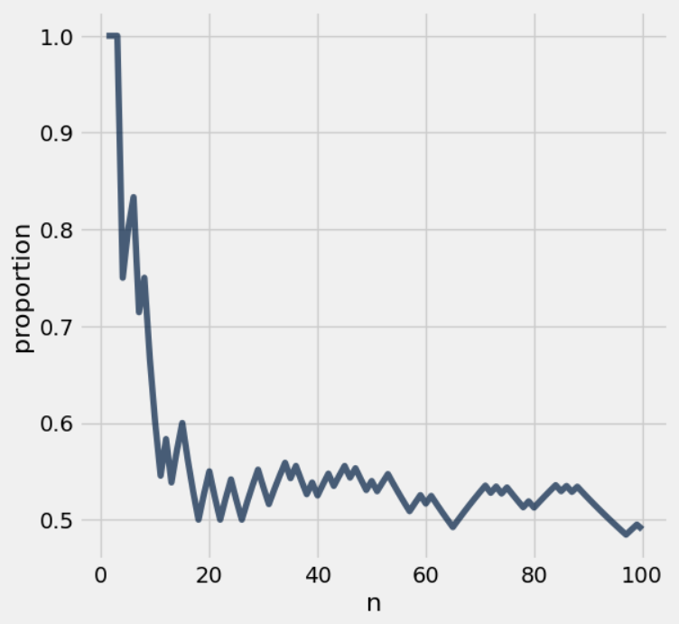
# of coin tosses | Proportion  $$p=\frac{X}{n}$$ | $$Var\left(Y\right)=\frac{\frac{X}{n}\left(1-\frac{X}{n}\right)}{n}$$ | # of coin tosses | Proportion  $$p=\frac{X}{n}$$ | $$Var\left(Y\right)=\frac{\frac{X}{n}\left(1-\frac{X}{n}\right)}{n}$$
10 | 0.6 | 0.024 | 60 | 0.516667 | 0.00416204
20 | 0.55 | 0.012375 | 70 | 0.528571 | 0.00355977
30 | 0.533333 | 0.0082963 | 80 | 0.5125 | 0.00312305
40 | 0.525 | 0.00623437 | 90 | 0.522222 | 0.00277229
50 | 0.54 | 0.004968 | 100 | 0.49 | 0.002499

